TECHNICAL PROJECT DOCUMENTATION
RetailMart Data Pipeline Project

1. Project Overview
RetailMart Pvt. Ltd. collects daily sales data from multiple retail stores. The data is stored in different CSV files and contains real-world data quality issues such as missing values, duplicate records, and incorrect data formats.
The objective of this project is to build a simple data pipeline that ingests raw data, performs data cleaning and transformation, stores the processed data into a database, and generates business insights for reporting.
The pipeline combines sales transactions with product and store information to create a final analytical dataset that helps the business understand:
- Best-selling products across different cities
- Revenue generated by each store per day
- Data quality issues in products and stores
- Overall sales performance insights

2. Project Approach
The project follows an ETL (Extract, Transform, Load) approach.

Step 1: Data Ingestion (Extract)
The first step is to collect data from the available CSV files:
- sales_data.csv
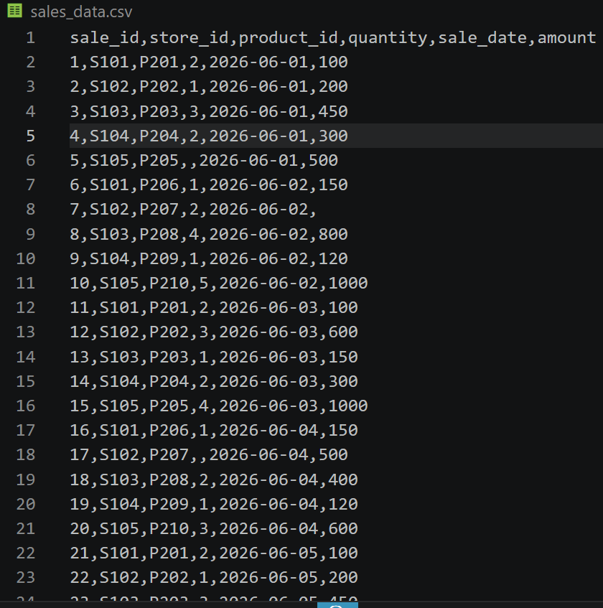
- products.csv
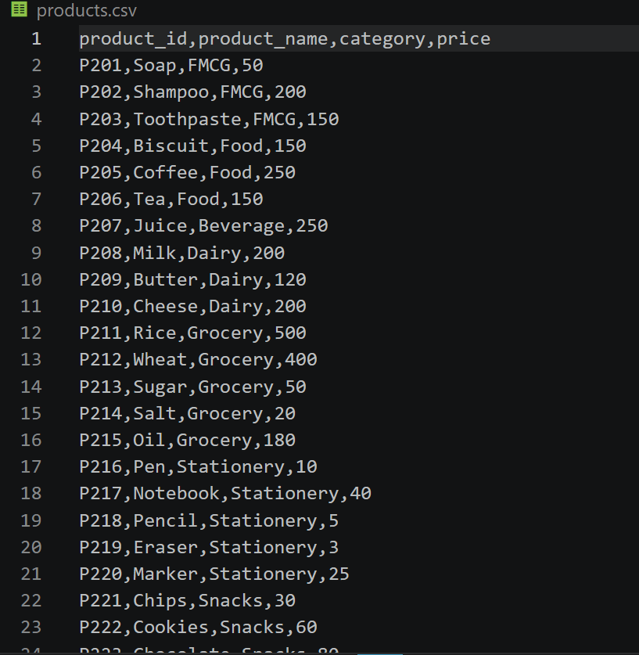
- stores.csv
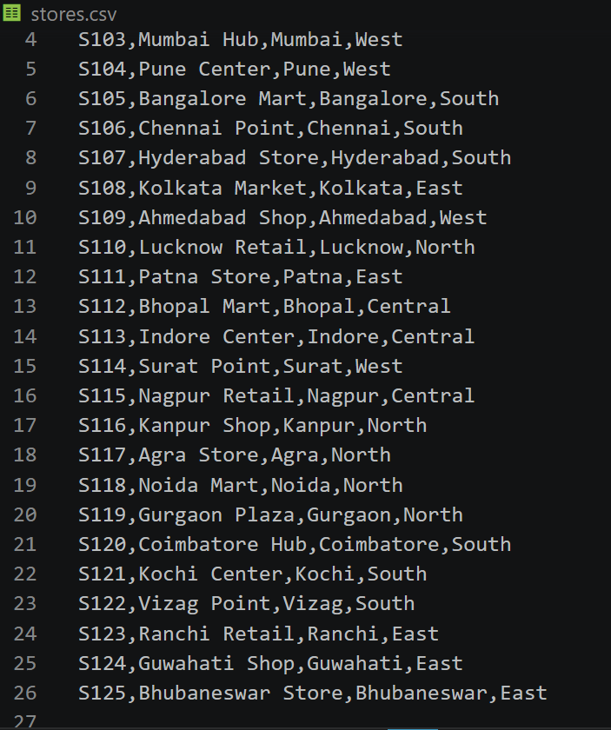
Using Python Pandas, all three files are loaded into separate DataFrames.
Initial data inspection is performed by:
- Checking dataset shape
- Displaying first five records
- Identifying missing values in each column
This helps understand the structure and quality of raw data before processing.

Step 2: Data Cleaning (Transform)
The raw sales data contains common data issues, so cleaning operations are performed.
The following cleaning steps are applied:

Removing Duplicate Records
Duplicate transactions are identified and removed from the sales dataset to avoid incorrect revenue calculations.

Handling Missing Values
- Missing values in the quantity column are replaced with 0.
- Rows where the amount field is missing are removed because revenue calculation cannot be performed without transaction amounts.

Data Type Conversion
Data formats are standardized:
- sale_date is converted into datetime format.
- amount is converted into float data type.
These steps ensure the data is accurate and ready for analysis.

Step 3: Data Transformation
After cleaning, the datasets are combined using joins.
The sales data is merged with:
- Products dataset using product_id
- Stores dataset using store_id
A final merged dataset is created containing:
- Transaction details
- Product information
- Store details
A new column called total_revenue is created using:
total_revenue = quantity × price
Using NumPy, statistical analysis is performed to calculate:
- Average revenue
- Maximum revenue
- Minimum revenue
Further analysis is performed by grouping data based on city to identify total revenue generated from each location.

Step 4: Data Loading
The processed dataset is loaded into a SQLite database.
A database table named:
retail_sales
is created to store the cleaned and transformed data.
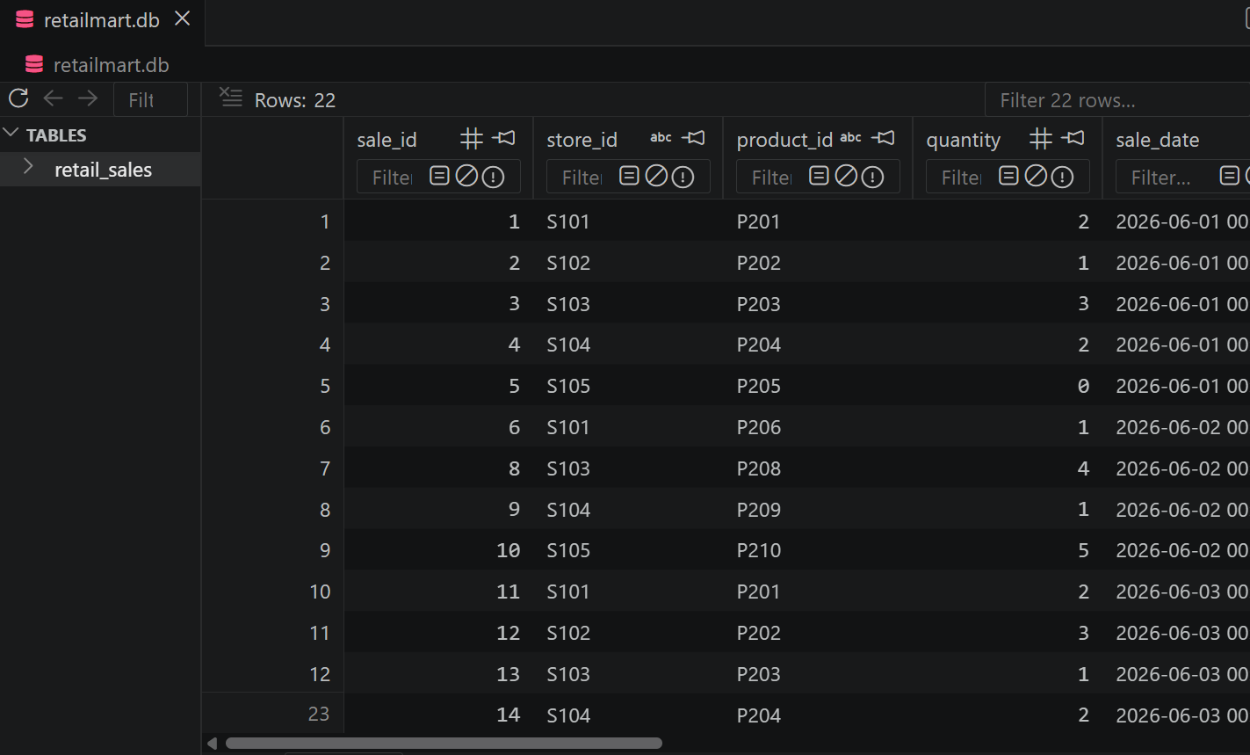
SQL queries are executed to generate business reports such as:
- Top 3 best-selling products by quantity sold
- Total revenue generated per store per day

Step 5: Reporting and Insights
A summary report is generated using Python.
The report provides:
- Total number of transactions
- Total revenue generated
- Top performing city
- Best-selling product
These insights help the business team make better decisions using data-driven analysis.

Step 6: Pipeline Automation and Error Handling
A function named run_pipeline() is created to execute the complete workflow in one call.
The pipeline includes:
- Data loading
- Data cleaning
- Data transformation
- Database loading
Basic exception handling is implemented using try-except blocks.
If any input file is missing or an unexpected error occurs, the pipeline displays an appropriate error message instead of stopping unexpectedly.

3. Technology Stack Used

Python
Python is used as the main programming language because it provides powerful libraries for data processing, automation, and database integration.
It is widely used in data engineering workflows because of its simplicity and flexibility.

Pandas
Pandas is used for handling CSV files and performing data manipulation.
It helps in:
- Loading datasets
- Cleaning missing values
- Removing duplicates
- Merging multiple datasets
- Performing grouping and aggregation operations
Pandas is one of the most commonly used libraries for data analysis and ETL pipelines.

NumPy
NumPy is used for numerical calculations and statistical operations.
In this project, it is used to calculate:
- Mean revenue
- Maximum revenue
- Minimum revenue
It provides fast and efficient mathematical operations on datasets.

SQLite
SQLite is used as the database for storing the final processed data.
It is selected because:
- It is lightweight and easy to integrate with Python
- It does not require a separate database server
- It supports SQL queries for data analysis
The cleaned dataset is stored in the retail_sales table for reporting purposes.

SQL
SQL is used for querying the stored data.
SQL helps generate business reports such as:
- Top-selling products
- Store-wise daily revenue
It provides an efficient way to analyze structured data stored in databases.

CSV Files
CSV files are used as input data sources because they are commonly used for exchanging and storing tabular business data.
The project simulates a real-world situation where organizations receive raw data from multiple sources in CSV format.
Raw CSV Files
↓
Data Ingestion using Pandas
↓
Data Quality Checking
↓
Data Cleaning and Transformation
↓
Data Merging
↓
Revenue Calculation and Analysis
↓
Load Data into SQLite Database
↓
Generate Reports and Business Insights

4. Project Workflow

Code:-

import pandas as pd

import numpy as np

import sqlite3

def run_pipeline():

try:

# Load files

sales_df = pd.read_csv("sales_data.csv")

products_df = pd.read_csv("products.csv")

stores_df = pd.read_csv("stores.csv")

print("Files loaded successfully!")

# Remove duplicates

sales_df = sales_df.drop_duplicates()

# Handle missing values

sales_df['quantity'] = sales_df['quantity'].fillna(0)

sales_df = sales_df.dropna(subset=['amount'])

# Convert datatypes

sales_df['sale_date'] = pd.to_datetime(sales_df['sale_date'])

sales_df['amount'] = sales_df['amount'].astype(float)

# Merge data

merged_df = pd.merge(

sales_df,

products_df,

on='product_id',

how='left'

)

merged_df = pd.merge(

merged_df,

stores_df,

on='store_id',

how='left'

)

# Create revenue column

merged_df['total_revenue'] = (

merged_df['quantity'] * merged_df['price']

)

# Revenue by city

city_revenue = (

merged_df.groupby('city')['total_revenue']

.sum()

.sort_values(ascending=False)

)

# Load into SQLite

conn = sqlite3.connect("retailmart.db")

merged_df.to_sql(

"retail_sales",

conn,

if_exists="replace",

index=False

)

conn.close()

# Summary Report

total_transactions = len(merged_df)

total_revenue = merged_df['total_revenue'].sum()

top_city = city_revenue.idxmax()

top_product = (

merged_df.groupby('product_name')['quantity']

.sum()

.idxmax()

)

print("\n===== SUMMARY REPORT =====")

print("Total Transactions :", total_transactions)

print("Total Revenue :", total_revenue)

print("Top Selling City :", top_city)

print("Top Selling Product:", top_product)

print("\nPipeline executed successfully!")

except FileNotFoundError as e:

print("File not found:", e)

except Exception as e:

print("An error occurred:", e)

Output:-

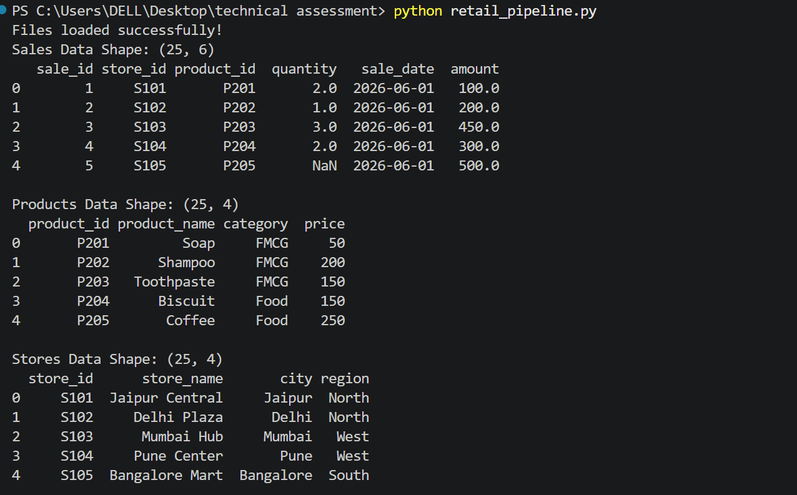

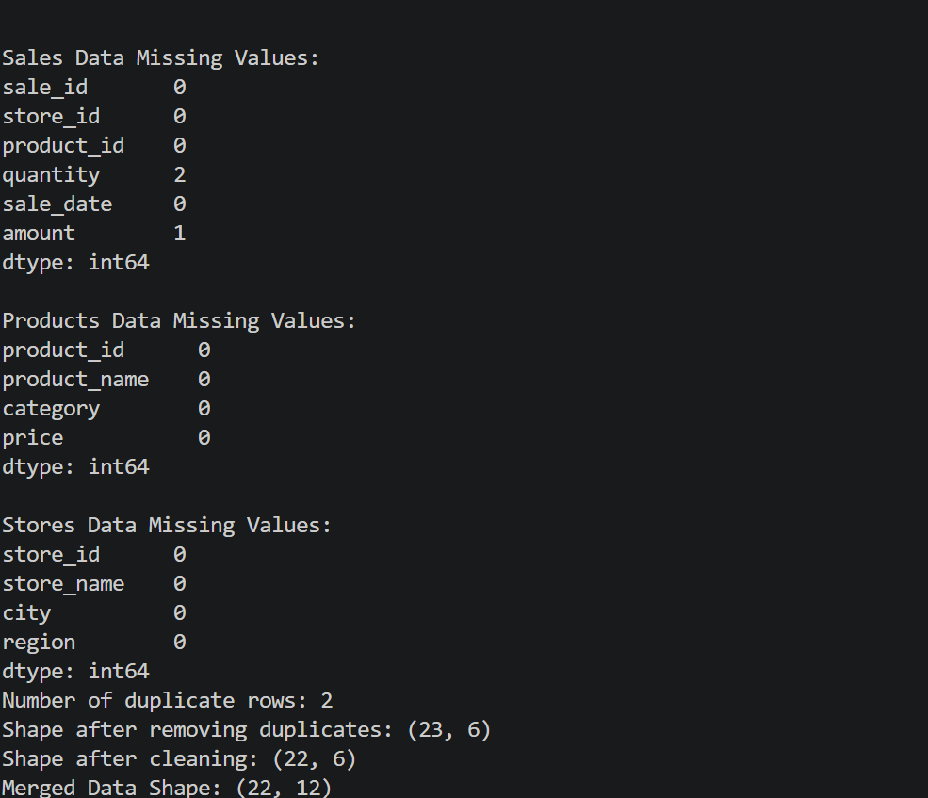

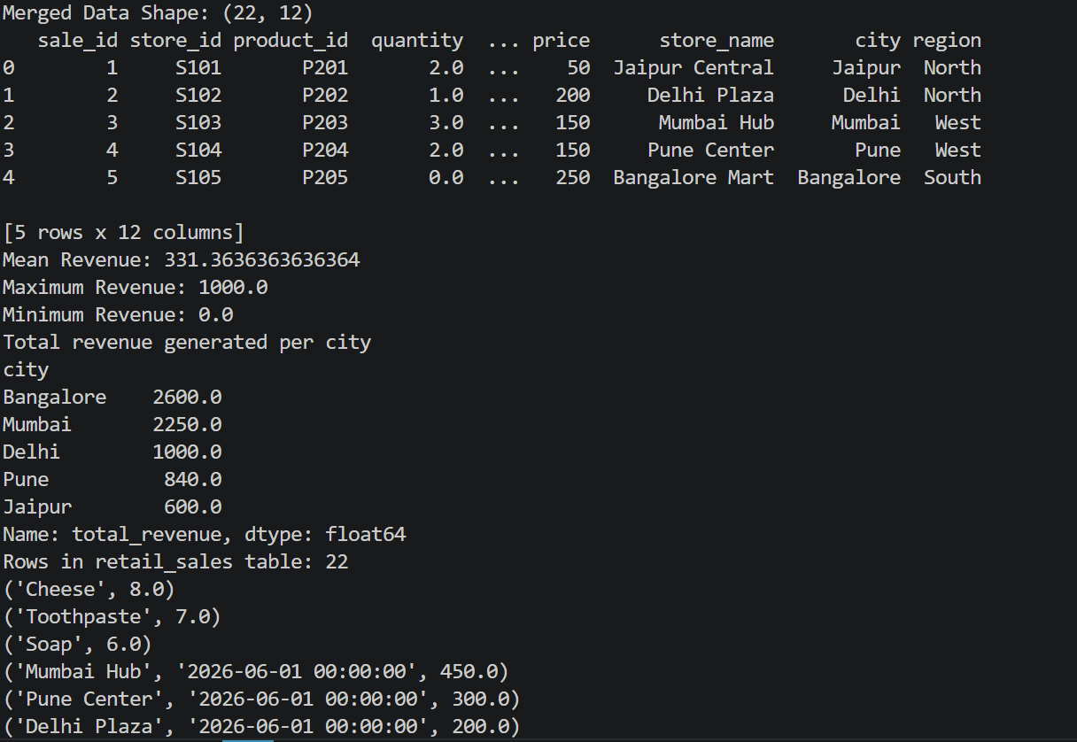

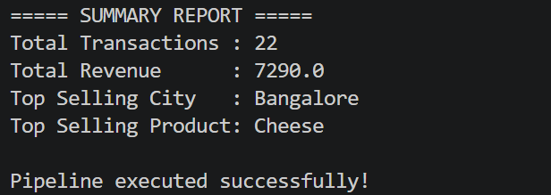

5. Conclusion
This project demonstrates a complete beginner-level data engineering pipeline using Python. It performs data ingestion, cleaning, transformation, database loading, and reporting.
The solution helps RetailMart convert raw sales data into meaningful business information that can support decision-making and future analytics requirements.

